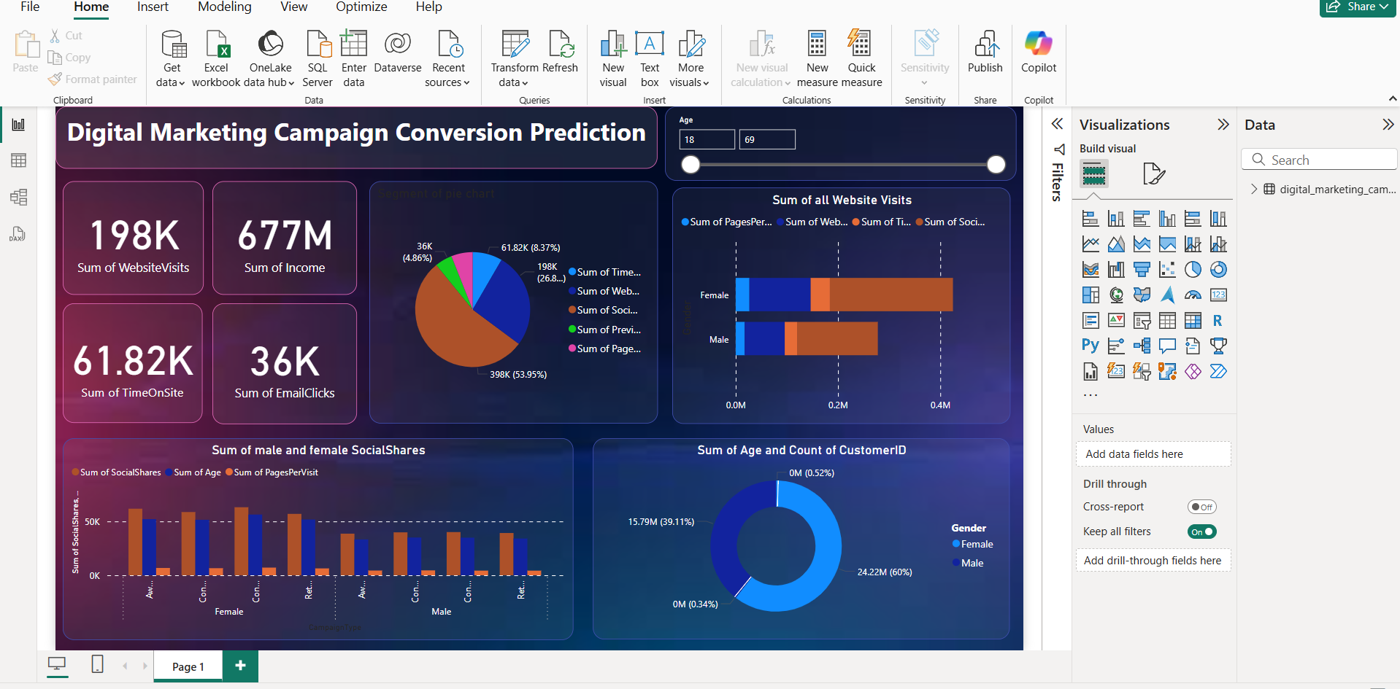

**Digital Marketing Campaign Conversion Prediction Dashboard Analysis**

This Power BI dashboard is designed to analyze and predict conversion trends in a digital marketing campaign. It provides key performance indicators (KPIs) and visualizations to help marketers assess campaign effectiveness.

**Key Metrics (Cards at the Top Left)**

1. **198K - Sum of Website Visits**
   * Tracks the total number of website visits.
   * Helps in understanding the reach of the campaign.
2. **677M - Sum of Income**
   * Displays the total revenue generated from the campaign.
   * Essential for measuring the financial impact of marketing efforts.
3. **61.82K - Sum of Time on Site**
   * Represents the total duration users spend on the website.
   * Longer durations indicate better engagement and user interest.
4. **36K - Sum of Email Clicks**
   * Measures the total number of email interactions.
   * Useful for evaluating the effectiveness of email marketing strategies.

**Graphs and Their Purpose**

1. **Pie Chart (Segment Breakdown)**
   * Displays the proportion of different campaign performance metrics such as:
     + Time on Site
     + Website Visits
     + Social Shares
     + Pages Per Visit
   * Helps in visualizing how different factors contribute to overall engagement.
2. **Horizontal Bar Chart (Sum of All Website Visits)**
   * Compares website visits by gender (Male vs. Female).
   * Identifies which demographic is more active in interacting with the campaign.
   * Useful for targeting marketing efforts more effectively.
3. **Grouped Bar Chart (Sum of Male and Female Social Shares)**
   * Analyzes how social sharing varies by gender and campaign type.
   * Indicates whether men or women are more likely to share content.
   * Provides insights for social media marketing strategies.
4. **Donut Chart (Sum of Age and Count of Customer ID by Gender)**
   * Breaks down users by age and gender.
   * Shows the proportion of male and female participants in the campaign.
   * Helps in demographic-based campaign targeting.

**Why These Graphs Are Used?**

* **KPIs (Cards)** → Provide a quick summary of performance.
* **Pie Chart** → Shows contribution of different engagement metrics.
* **Bar Charts** → Compare performance across demographics (gender, campaign type).
* **Donut Chart** → Highlights user distribution by age and gender.

This dashboard helps marketers track the effectiveness of their digital campaigns, identify key trends, and make data-driven decisions for better targeting and improved conversions. 🚀

Q] This dashboard is perfect from this information Features Demographic Information?

Your dataset is well-structured for analyzing digital marketing campaign performance, and the dashboard effectively visualizes key aspects of customer engagement, demographics, and conversions.

Here’s how the dashboard aligns with your dataset features:

**1. KPI Cards (Top Metrics)**

* **Sum of Website Visits (198K)** → Represents total visits from *WebsiteVisits*.
* **Sum of Income (677M)** → Aggregates customer *Income* to understand audience purchasing power.
* **Sum of Time on Site (61.82K)** → Measures engagement from *TimeOnSite*.
* **Sum of Email Clicks (36K)** → Evaluates *EmailClicks* effectiveness.

**2. Pie Chart (Segment Breakdown)**

* Displays key engagement metrics like *WebsiteVisits, TimeOnSite, SocialShares, PagesPerVisit*.
* Useful for comparing different factors that drive conversions.

**3. Horizontal Bar Chart (Website Visits by Gender)**

* Uses *Gender* to segment *WebsiteVisits*.
* Helps identify whether male or female audiences engage more with the campaign.

**4. Grouped Bar Chart (SocialShares by Campaign Type & Gender)**

* Maps *SocialShares* against *CampaignType* and *Gender*.
* Provides insights into which campaigns are driving social engagement.

**5. Donut Chart (Age & Conversion Count by Gender)**

* Segments customers based on *Age* and *Gender*.
* Can reveal which demographic is more likely to convert.

This dashboard is well-optimized for conversion analysis. If needed, you could further enhance it by adding: ✅ **AdSpend Analysis** – Show how budget affects conversions.  
✅ **ClickThroughRate & ConversionRate Trends** – Compare performance across different *CampaignChannels*.  
✅ **Loyalty & Previous Purchases Impact** – Understand if repeat customers convert more.

Would you like help adding any additional insights to this dashboard? 🚀